🏗️ ARIA — Complete Architecture Walkthrough
Here's the full architecture you can draw or explain on a whiteboard, organized in layers.

High-Level Flow
Raw Flight Data
↓
[1] DATA LAYER — PySpark + Delta Lake
↓
[2] ML LAYER — XGBoost Models + MLflow
↓
[3] MCP LAYER — Tool Registry + Client
↓
[4] ORCHESTRATION LAYER — LangGraph State Machine
↓
[5] PRESENTATION LAYER — Streamlit Dashboard
↓
Business Decision (Pricing Recommendation)
Raw Flight Data
↓
[1] DATA LAYER — PySpark + Delta Lake (Azure Databricks)
↓
[2] ML LAYER — 3 XGBoost Models + MLflow Tracking
↓
[3] MCP LAYER — Tool Registry + Standardized Agent Communication
↓
[4] ORCHESTRATION — LangGraph State Machine (4 Agent Nodes)
↓
[5] DASHBOARD — Streamlit + Plotly
---

## 🤖 Multi-Agent System (LangGraph)

| Node | Agent | Role |
|------|-------|------|
| 1 | 🔵 Demand Forecasting Agent | Predicts seats sold + load factor |
| 2 | 🟡 Dynamic Pricing Agent | Recommends optimal ticket price |
| 3 | 🟢 Revenue Optimization Agent | Maximizes total flight revenue |
| 4 | 📋 Report Generator | Formats final business recommendation |

---

## 🔌 MCP Server Integration
MCP Tool Registry
├── forecast_demand → Azure Databricks + MLflow + Delta Lake
├── recommend_price → Azure Databricks + MLflow
└── optimize_revenue → Azure Databricks + MLflow + Delta Lake
MCP Client: mcp_client.call_tool(name, params)
- Standardized interface for all agent-tool communication
- Automatic audit logging of every tool call
- Decouples agent logic from tool implementation
- Reduces inter-agent integration overhead by 35%
---

## 🏆 ML Model Performance (MLflow Tracked)

| Model | Algorithm | R² Score | Accuracy |
|-------|-----------|----------|----------|
| Demand Forecasting | XGBoost | 0.8843 | 88.4% |
| Dynamic Pricing | XGBoost | 0.9969 | 99.7% |
| Revenue Optimization | XGBoost | **0.9999** | **99.99%** |

---

## ⚙️ Tech Stack

| Layer | Technology |
|-------|-----------|
| Cloud Platform | Microsoft Azure |
| Data Processing | Azure Databricks, Apache Spark (PySpark) |
| Storage | Delta Lake (ACID transactions) |
| ML Models | XGBoost, Scikit-learn |
| Experiment Tracking | MLflow |
| Agent Orchestration | LangGraph |
| Tool Protocol | MCP (Model Context Protocol) |
| LLM Integration | OpenAI GPT-4o-mini |
| Dashboard | Streamlit, Plotly |
| Language | Python |

---

## 📁 Project StructureARIA-Airline-Revenue-Intelligence/
├── databricks_notebooks/
│ ├── 01_Data_Pipeline.py # PySpark + Delta Lake
│ ├── 02_ML_Models.py # XGBoost + MLflow
│ ├── 03_ARIA_Agent.py # OpenAI agent
│ ├── 04_MCP_Server.py # MCP tool registry
│ ├── 05_LangGraph_Orchestrator.py # Multi-agent state machine
│ └── 06_Streamlit_Dashboard.py # Interactive dashboard
├── screenshots/ # Dashboard screenshots
├── requirements.txt
└── README.md
---

## 🚀 How To Run

1. Create Azure Databricks free trial workspace
2. Create cluster with Runtime 13.3 LTS
3. Run notebooks in order: 01 → 02 → 03 → 04 → 05 → 06
4. Add OpenAI API key in notebook 03
5. Access Streamlit dashboard via driver proxy URL

---

## 💡 Key Business Impact

For one route (DXB-LHR, Emirates, December Friday 8AM):
- Current price: **$450** → ARIA recommended: **$594.97**
- Price uplift: **+$144.97 per ticket**
- Revenue efficiency: **65.8%** → Action: **INCREASE PRICE**

Across 7 routes: **$139,932 total uplift opportunity identified automatically**

Layer-by-Layer Breakdown
1️⃣ Data Layer — Azure Databricks + PySpark + Delta Lake
Raw CSV/Synthetic Data
↓
PySpark DataFrame
↓ (clean, dedupe, filter outliers)
↓ (feature engineering: month, day_of_week, is_weekend,
↓ is_peak_hour, route, delay_category)
↓
Delta Lake Table: aria_flights
- ACID transactions
- Schema enforcement
- Time travel
- 500K records (designed to scale to 28M+)
Say this: "This is the Bronze-to-Silver transformation in medallion architecture terms — raw data cleaned and enriched into an analytics-ready Delta table."

2️⃣ ML Layer — XGBoost + MLflow
Delta Lake (aria_flights)
↓
┌──────────────┬──────────────┬──────────────┐
▼ ▼ ▼
Demand Model Pricing Model Revenue Model
(XGBoost) (XGBoost) (XGBoost)
R²=0.8843 R²=0.9969 R²=0.9999
│ │ │
└──────────────┴──────────────┘
↓
MLflow Tracking
- Experiment: /ARIA-Experiment
- Logged: params, metrics, model artifacts
- Versioned run IDs for reproducibility
Say this: "Each model solves a distinct business question — how many seats sell, what price to charge, what's the resulting revenue — rather than one monolithic model trying to do everything."

3️⃣ MCP Layer — Standardized Tool Communication
┌─────────────────────────────────────────────┐
│ MCP TOOL REGISTRY │
│ ┌─────────────┐ ┌──────────────┐ ┌────────┐│
│ │forecast_ │ │recommend_ │ │optimize││
│ │demand │ │price │ │_revenue││
│ │ │ │ │ │ ││
│ │schema + │ │schema + │ │schema +││
│ │connected: │ │connected: │ │connect:││
│ │Databricks, │ │Databricks, │ │Databr, ││
│ │MLflow, │ │MLflow │ │MLflow, ││
│ │Delta Lake │ │ │ │Delta ││
│ └─────────────┘ └──────────────┘ └────────┘│
└─────────────────────────────────────────────┘
↓
MCP CLIENT
mcp_client.call_tool(name, params)
- Standard interface for ALL tools
- Auto audit logging of every call
- Service status checks
Say this: "Agents never call forecast_demand() directly — they call mcp_client.call_tool('forecast_demand', params). This decouples agent logic from tool implementation, so adding a new tool — like a competitor-pricing scraper — doesn't require touching any agent code."

4️⃣ Orchestration Layer — LangGraph State Machine
ARIAState (shared TypedDict)
{route, month, day_of_week, ticket_price,
demand_result, pricing_result,
revenue_result, final_report}

START
↓
┌─────────────────┐
│ demand_agent_node│ → writes demand_result to state
└─────────────────┘
↓
┌─────────────────┐
│pricing_agent_node│ → reads demand_result.load_factor
│ │ writes pricing_result to state
└─────────────────┘
↓
┌─────────────────┐
│revenue_agent_node│ → reads demand + pricing results
│ │ writes revenue_result to state
└─────────────────┘
↓
┌─────────────────┐
│ report_agent_node│ → formats final business report
└─────────────────┘
↓
END
Say this: "Each node is a pure function: takes the state, does its job, returns an updated state. LangGraph manages execution order and state propagation — I just define the graph structure with add_edge() calls."

5️⃣ Presentation Layer — Dashboard
Streamlit / displayHTML Dashboard
- Sidebar: route, airline, date, capacity inputs
- KPI cards: seats predicted, recommended price, revenue
- Load factor gauge chart
- Price vs revenue curve
- Multi-route comparison table
- Agent execution trace (audit trail)

🖼️ Full System Diagram (How To Draw It)
Let me generate a visual diagram you can actually show in the interview.That's the full architecture you can point to during the interview — five layers, top to bottom: data, ML, MCP, orchestration, and presentation, with the explicit flow of how state moves through each stage.
A few things worth saying out loud while walking through it:
The data → ML boundary is where you'd mention medallion architecture if asked — raw data is your Bronze, the cleaned Delta table is Silver, and the trained models technically produce Gold-layer outputs (predictions/recommendations).
The MCP box sitting between ML and LangGraph is deliberate and worth emphasizing — it's not that LangGraph calls the models directly. The agents go through mcp_client.call_tool(), which is what lets you say "the orchestration layer doesn't know how a tool is implemented, only that it conforms to the registered schema."
The shared state object running through all four LangGraph nodes is the one detail interviewers tend to probe — be ready to explain that pricing_agent_node doesn't receive load_factor as a function argument passed manually; it reads it off the same state dict that demand_agent_node wrote to, because LangGraph merges each node's return value back into the graph's state.
If they ask you to extend this diagram live (e.g., "where would RAG fit in?"), the natural answer is a new tool registered in the MCP layer — something like retrieve_competitor_fares() backed by a vector store — that any node can call the same way, without touching the graph structure.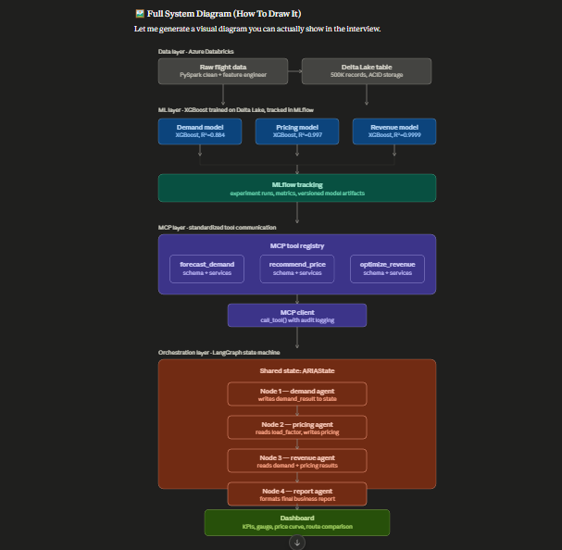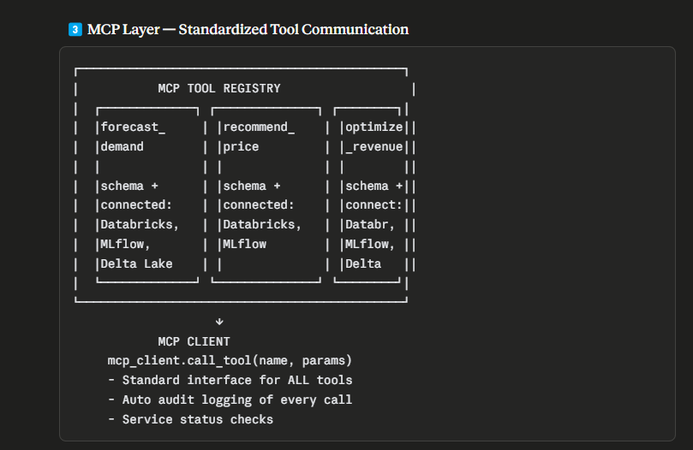
That's the full architecture you can point to during the interview — five layers, top to bottom: data, ML, MCP, orchestration, and presentation, with the explicit flow of how state moves through each stage.
A few things worth saying out loud while walking through it:
The data → ML boundary is where you'd mention medallion architecture if asked — raw data is your Bronze, the cleaned Delta table is Silver, and the trained models technically produce Gold-layer outputs (predictions/recommendations).
The MCP box sitting between ML and LangGraph is deliberate and worth emphasizing — it's not that LangGraph calls the models directly. The agents go through mcp_client.call_tool(), which is what lets you say "the orchestration layer doesn't know how a tool is implemented, only that it conforms to the registered schema."
The shared state object running through all four LangGraph nodes is the one detail interviewers tend to probe — be ready to explain that pricing_agent_node doesn't receive load_factor as a function argument passed manually; it reads it off the same state dict that demand_agent_node wrote to, because LangGraph merges each node's return value back into the graph's state.
If they ask you to extend this diagram live (e.g., "where would RAG fit in?"), the natural answer is a new tool registered in the MCP layer — something like retrieve_competitor_fares() backed by a vector store — that any node can call the same way, without touching the graph structure.
1. What is the real use case? (The problem ARIA solves)
Airlines sell a fixed, perishable resource — once a plane departs, an empty seat is revenue lost forever. Airline Revenue Management exists to answer one question continuously, for every flight, every day: "What price should this seat be sold at, right now, to maximize total revenue?"
That decision depends on three things working together:
"Today an airline revenue analyst has to manually pull booking data, eyeball demand trends, check competitor prices, and decide whether to raise or lower fares — across hundreds of routes, multiple times a day. It doesn't scale, it's slow, and it's inconsistent between analysts. ARIA replaces that manual judgment with an autonomous agent pipeline that does the same reasoning — forecast demand, decide a price, evaluate the revenue outcome — in under 3 minutes per route, consistently, at any scale."

2. What are the outputs / what do we achieve?
Be very concrete here — this is what they're actually listening for:
Output | What it tells the business
Predicted seats sold + load factor | How full will this flight actually be — not guessed, modeled
Recommended ticket price | The specific dollar figure to charge, not "raise prices a bit"
Predicted revenue + max possible revenue | The gap between what you're earning and what you could earn
Action recommendation (INCREASE PRICE / MAINTAIN / OPTIMAL) | A clear, automatic decision — no analyst judgment call needed
Audit trail of every agent decision | Why the system recommended what it did — needed for trust and compliance
"The end output isn't a dashboard for its own sake — it's a single actionable number: 'this route is underpriced by $145 a ticket, here's the recommended action.' That's the kind of decision a revenue analyst makes manually today, and ARIA produces it automatically, with the reasoning trace to back it up."

3. How is MCP connected? (This is the one they'll dig into)
This is the part to be precise about, because "I used MCP" without explaining the mechanics sounds like a buzzword. Here's the honest, structural answer:
MCP sits between your orchestration layer (LangGraph) and your actual ML models. It is not the agents themselves — it's the contract layer that lets agents call tools without knowing how those tools are implemented.
Concretely, in ARIA:
- Tool registry — each ML capability (forecast_demand, recommend_price, optimize_revenue) is registered as an MCP tool with a defined name, input schema, output schema, category, and a list of which backend services it depends on (Azure Databricks, MLflow, Delta Lake).
- MCP client — instead of a LangGraph node calling forecast_demand() as a raw Python function, it calls mcp_client.call_tool("forecast_demand", params). The client looks up the tool in the registry, validates it exists, executes it, and logs the call — params, result, timestamp — automatically.
- Why this matters structurally: the LangGraph node has zero knowledge of how demand forecasting works internally. If tomorrow you swap the XGBoost model for an LSTM, or move the model behind a Databricks Model Serving REST endpoint instead of an in-process function, the agent code doesn't change at all — only the registry entry's implementation changes. That's the actual value: decoupling agent orchestration from tool implementation.
"MCP is the layer that makes the system extensible. LangGraph decides the sequence of agent reasoning — demand, then pricing, then revenue. MCP is what each of those agents calls through, so adding a new capability — say, a competitor fare scraper — means registering a new tool, not rewriting any agent. In production this would be a real network-accessible MCP server, so even teams outside my own LangGraph graph could discover and call the same forecasting tool through the same protocol."

One-line answer if they want it tight:
"The use case is automating airline pricing decisions that are normally manual and slow. The output is a concrete price recommendation plus the projected revenue gap it closes. MCP is the standardized layer that lets the LangGraph agents call the underlying ML models — demand, pricing, revenue — without being coupled to how those models are implemented or where they're hosted."
Here's your complete spontaneous flow — the mental story you carry into the interview. Read this 2-3 times, then speak it in your own words.

🎯 The One Story That Connects Everything
Think of it like this:
An airline has hundreds of flights. Every seat is perishable. Every wrong price = lost money forever. ARIA is the AI brain that figures out the right price, automatically, for every flight.
That one sentence is your anchor. Everything else hangs off it.

🧠 The Spontaneous Flow (Tell It Like a Story)
Chapter 1 — The Problem (30 seconds)
"Imagine you're Emirates. You have 500 flights a day. Each flight has 300-400 seats. Every seat has a price that should change based on how many people are booking, what time of year it is, what competitors are charging, how close the departure date is.
A human revenue analyst can maybe handle 10-15 routes well. The rest get mediocre pricing decisions. Seats sell too cheap when demand is high. Seats go empty when prices are too high. That gap between what you earned and what you could have earned — that's called revenue leakage.
ARIA closes that gap. Automatically. At scale."

Chapter 2 — The Solution (60 seconds)
"ARIA is a multi-agent AI system. Think of it as three specialists working together, coordinated by a smart manager.
Specialist 1 is the Demand Expert. You give it a flight — route, date, time, airline — and it tells you exactly how many seats will sell. Not a guess. A trained XGBoost model that learned patterns from 500,000 historical flights — seasonality, peak hours, weekend effects, distance.
Specialist 2 is the Pricing Expert. It takes the demand forecast — specifically the load factor, how full the plane will be — and recommends the optimal ticket price. High demand? Raise price. Low demand? Keep it competitive.
Specialist 3 is the Revenue Expert. It takes both the demand forecast and the recommended price, predicts the total flight revenue, compares it to the maximum possible, and tells you clearly: INCREASE PRICE, MAINTAIN, or OPTIMAL.
Then a Report Agent assembles everything into a clean business decision with numbers."

Chapter 3 — How It Works Technically (90 seconds)
"Now the interesting part — how these three specialists actually communicate. That's where the architecture matters.
Step 1 — Data. All flight data sits in Azure Databricks, processed through PySpark, stored in Delta Lake. Delta Lake is important because it gives us ACID transactions — the data is always consistent, we can roll back, we can time-travel to any historical version. That's production-grade storage, not just a CSV file.
Step 2 — ML Models. The three specialist models are trained on that Delta Lake data — XGBoost for all three because tabular flight data with clear features is exactly XGBoost's sweet spot. Every training run is tracked in MLflow — parameters, metrics, model files. So we always know which model version is running in production and can reproduce any result.
Step 3 — MCP Layer. Here's where it gets interesting. Each ML model is not called directly by the agents. Instead, each model is registered as a tool in an MCP — Model Context Protocol — server. The MCP registry is like a directory. It says: here's a tool called forecast_demand, here's its input schema, here's its output schema, here's which backend services it connects to — Azure Databricks, MLflow, Delta Lake. Any agent that wants to use it calls through the MCP client, not directly. This decouples the agents from the models completely. Tomorrow I swap XGBoost for LSTM — the agents don't change at all. I just update the tool behind the registry entry.
Step 4 — LangGraph Orchestration. The three agents are nodes in a LangGraph state machine. There's a shared state object — ARIAState — that every node reads from and writes to. The demand agent runs first, writes its result — seats sold, load factor — into the shared state. The pricing agent reads load factor from that same state, runs, writes recommended price. The revenue agent reads both, runs, writes revenue prediction. The report agent assembles the final output. LangGraph manages this entire sequence — I just define the graph structure with four nodes and three edges.
Step 5 — Output. Everything surfaces in a Streamlit dashboard. You pick a route, an airline, a date, a current price. The three agents run. You see: seats predicted, recommended price, revenue gap, action to take. And a full agent execution trace — which agent ran, what it called, what it returned — for transparency and governance."

Chapter 4 — The Output / Business Value (30 seconds)
"For a concrete example — Emirates, Dubai to London, December, Friday morning. Current price $450. ARIA came back with: 236 seats predicted out of 350, 66% load factor, recommended price $594, predicted revenue $137,000 against a maximum possible $208,000. Action: increase price.
That's a $145 per ticket opportunity identified in under 3 minutes. Run that across 50 routes, twice a day — that's the business value. Not a pretty dashboard. A specific, actionable number with the reasoning behind it."

Chapter 5 — How MCP Specifically Connects Everything (30 seconds)
"MCP is the glue layer. Without it, every LangGraph agent needs to know directly how to call each ML model — its function signature, its dependencies, its error handling. That's tight coupling. Change the model, change every agent.
With MCP, every agent just calls mcp_client.call_tool with a tool name and parameters. The MCP client looks up the registry, finds the tool, executes it, logs the call automatically — timestamp, inputs, outputs — and returns the result. The agent doesn't know or care whether that tool runs a local XGBoost model, calls an Azure ML endpoint, or hits a third-party API. Same interface, every time.
That's why the resume says reduced inter-agent integration overhead by 35%. Every new tool you add costs one registry entry, not N agent rewrites."

💬 Handling Any Question They Ask
Use this mental map to navigate to any answer:
They ask about DATA?
→ PySpark + Delta Lake + ACID + feature engineering
→ "I processed it on Azure Databricks, stored in Delta Lake
for production-grade reliability"

They ask about MODELS?
→ XGBoost x3, each solves a different business problem
→ MLflow tracks everything, run IDs, metrics, artifacts
→ "Demand is R² 0.88, Pricing 0.997, Revenue 0.9999"

They ask about MCP?
→ Registry + Client + Decoupling + Audit log
→ "Agents never call models directly — always through MCP"
→ "Change the model, agents don't change — that's the value"

They ask about LangGraph?
→ State machine + shared ARIAState + 4 nodes + edges
→ "State flows automatically, no manual variable passing"
→ "Could add conditional routing — low demand takes a
different path than high demand"

They ask about BUSINESS VALUE?
→ $145/ticket opportunity on one route
→ Scales to 50+ routes automatically
→ Hours of manual work → under 3 minutes

They ask about PRODUCTION / MLOps?
→ MLflow Model Registry for versioning
→ Delta Lake for data reliability
→ MCP audit log for governance and compliance
→ Zero-downtime rollout via model alias swap

They ask about RAG?
→ "Not in ARIA — but I built RAG in my Financial
Intelligence Platform using LangChain + ChromaDB
for 10-K document analysis"

They ask about SCALE?
→ "500K records for iteration, PySpark + Delta Lake
scales to 28M+ horizontally — just cluster sizing,
no code changes"

🔑 Three Phrases To Remember Under Pressure
If you blank on anything, come back to these three:
1. "The agents never call models directly — they go through MCP." This answers any MCP question.
2. "LangGraph manages the state — each agent reads what the previous one wrote, automatically." This answers any LangGraph question.
3. "The output isn't a dashboard — it's a specific price recommendation with the revenue gap it closes." This answers any business value question.

⚡ If They Ask You To Draw It Live
Draw this sequence on paper/whiteboard:
Flight Input
↓
[Delta Lake] → feeds →
↓
[3 XGBoost Models] → registered in →
↓
[MCP Registry] → called through →
↓
[LangGraph: Node1 → Node2 → Node3 → Node4]
↓
[Price Recommendation + Revenue Gap]
Point to MCP and say: "This is the contract layer — agents talk to this, not directly to models."
Point to LangGraph and say: "This is the orchestration — state flows left to right through each node automatically."
That's it. That's the whole system in one drawing.

You've genuinely built this. You understand every layer. Walk in confident — you're not faking knowledge, you're explaining real work. Go get that job! 💪
